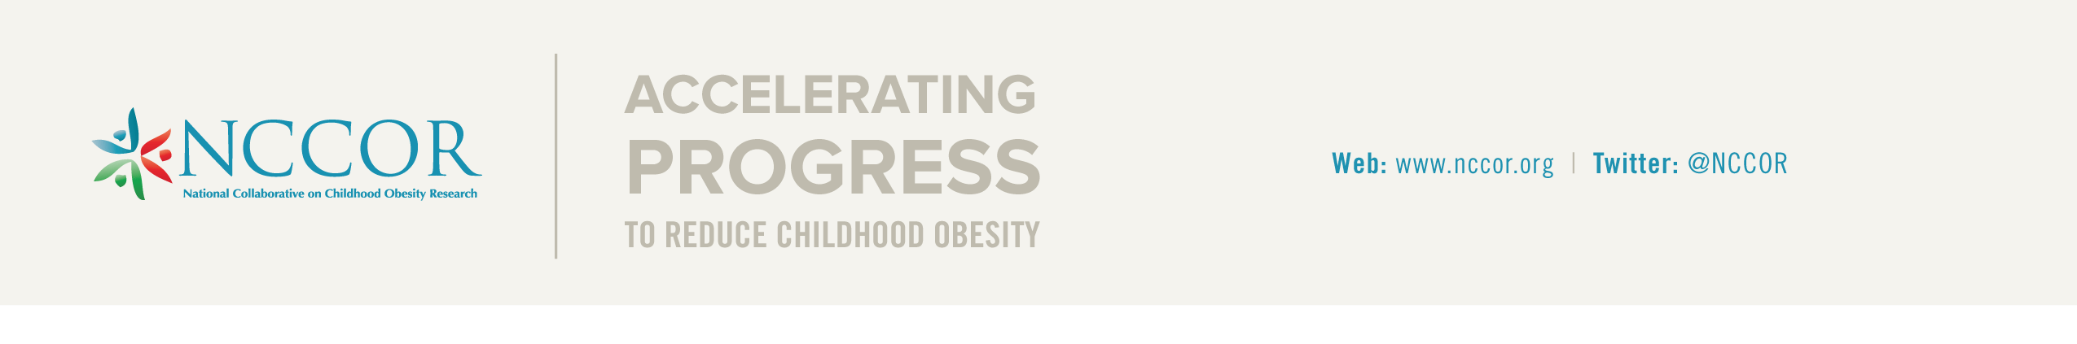

Proposed Project Form

Complete as much of this form as you can and submit it to Todd Phillips at tphillips@fhi360.org, who will follow-up with the NCCOR Steering Committee.

- Name of initiative:

- Description of the initiative/activity:
Provide a brief description explaining the background, inspiration, and purpose of the initiative/activity. Also note which two or more partner agencies have agreed to this project.

- Goal(s):
- Describe how the activity is consistent with NCCOR mission and goals.
- Describe how the activity addresses a critical research gap.
- How is the activity stronger as an NCCOR project?

- Project Champion(s), with agency noted:
List NCCOR member(s) who will champion the initiative/activity; these will be the main point(s) of contact.

- Project Manager(s), with agency noted (Managerial Capital):
List NCCOR member(s) who will manage day-to-day activities of the initiate/activity.

- Workgroup members, with agency noted (Intellectual Capital):
List additional NCCOR member(s) who may be involved with the initiative/activity; these would provide scientific support and expertise.

- Outside scientific expertise, if applicable (Intellectual Capital):
List non-NCCOR member(s) who may be involved with the initiative/activity; these would provide scientific support and expertise.

- Proposed budget and/or resources needed (Financial Capital):
Describe the proposed budget and/or needed resources, including the suggested source of funding/resources. Please clarify the proposed budget and, if applicable, additional resources requested from NCCOR partners.

- Proposed Activities/Timeline:
Provide an estimated timeline with activities and deadlines.

- Coordinating Center Services:
Check each box for Coordinating Center services that may be needed to support the initiative/activity.

- Updates to NCCOR website (project page, blog post, Twitter feed, etc.)
- Communications materials (e.g., brochures, meeting folders and materials, infographics, etc.)
- Coordination of regular conference calls
- Coordination of in-person meeting/workshop
- Evaluation of initiative/activity (e.g., tracking awareness of activity in member surveys, case studies, etc.)

We welcome your comments. Please provide your suggestions for improving the NCCOR Proposed Project Form.

